Project Assingment 1 & 2 (P1P2)
Team #22
Team members:
Bader AlKhawashki, Arunima Basu, Fritz Kuermayr, Aman Shah, Salvador Gonzalez

Deliverable 1: Team Project Agreement (for future reference)

1) Shop training:
Fritz Kuermayr will undergo the shop training. Aman Shah & Salvador Gonzalez will assist in the hardware, software, shop aspects, and other miscellaneous tasks

2) Sourcing parts:
Arunima Basu will be responsible for this aspect of the project, as well as communication with the teaching staff for the grant.

3) Deadlines:
Bader AlKhawashki will be responsible for project documentation (written tasks), submitting the work, and keeping track of project deadlines, which includes reminders to the team and team members.

4) Absence procedure that your team can use to address future concerns like these if they arise.
Emails and messages will be sent multiple times prior to escalating the issue to the teaching team.

Deliverable 2:
For farmers/gardeners who own greenhouses, it’s a robot that detects local humidity within a greenhouse and if it falls below a certain threshold, the robot extends a mechanism that sprays water mist and moves around the greenhouse to ensure proper humidification of the entire area. It also sprays nutrients on the soil every set number of hours using a retractable mechanism.
* Subject to Change.

(We opt in to be considered by the grant since this project improves the environment by taking care of plants in greenhouses.)

Deliverable 3:
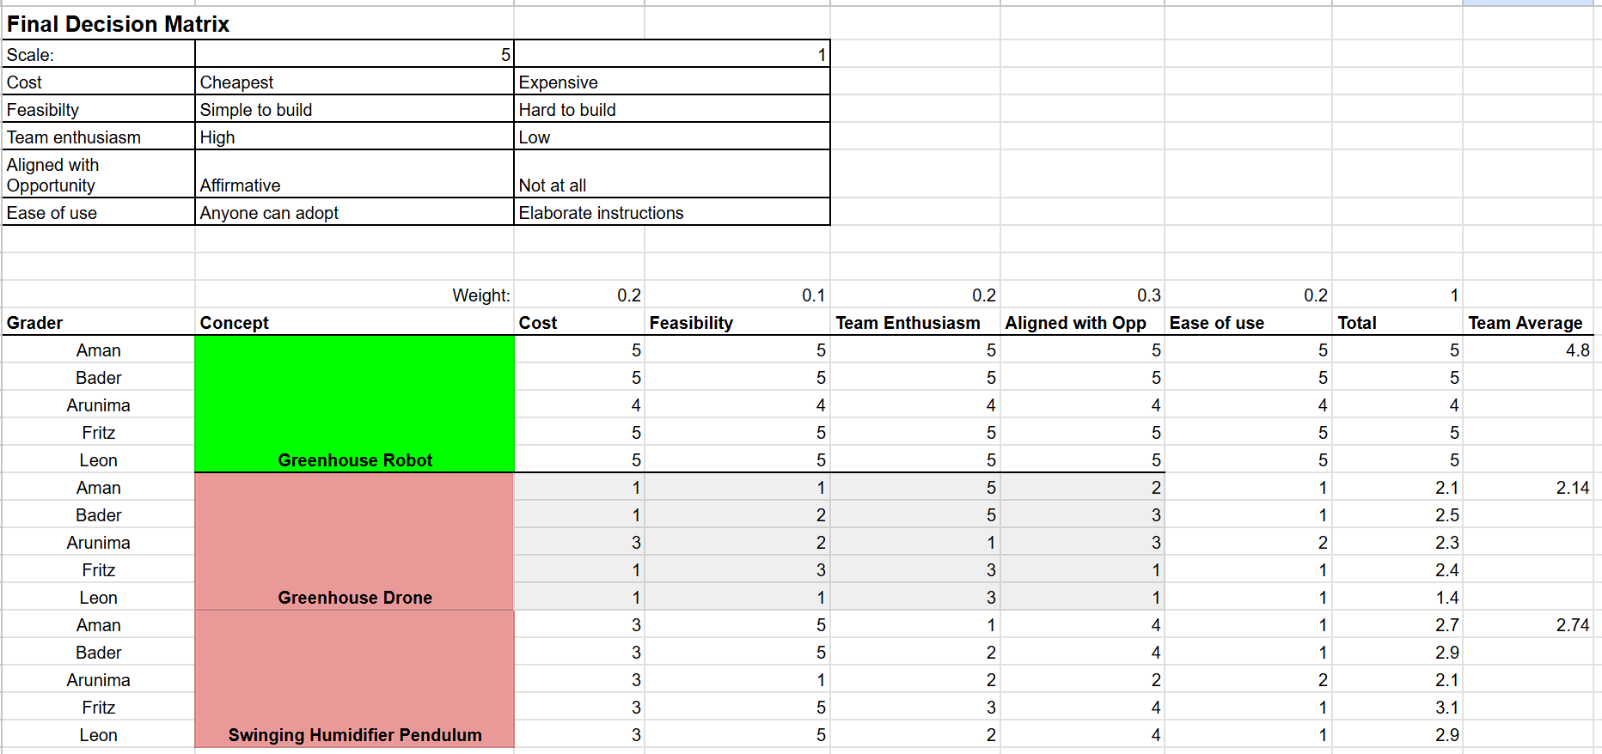
Our Greenhouse robot scored the best, and we chose it as our primary concept prototype.

Deliverables 4 (Imported our slides below)

